The PIT Archive – Home Page

- Welcome Compliance Officer of <<Company Name>>.
<<Company Name>> derives from the Company Name mentioned in Company Master Data.
- Beside “Logout” tab we can put “Master Data of Company” in the Right
- Instead of Part A, lets divide into three parts:
- Recording of Information
- Connected Person (CP)
- Insider (IP)
- Sharing of Unpublished Price Sensitive Information (UPSI)
- Reports
- List of Connected Person’s
- List of Insider’s
- List with whom UPSI is Shared
- List of PAN’s Registered under Database
- Audit Trail of Information of Database
- Data Management
- Backup Data
- Restore Data

The PIT Archive – Connected Person

- What is the logic for “Insert” Tab – Kindly remove if of no use and shift update button to bottom.
- Change the Connect Person ID to Connected Person ID.
- Let’s create permanent address and residential address text box
- Enter beside option of PAN or any other identifier no. <<Text Block>>
- Change the Mobile No. to Landline/Mobile No.
- Change the Demat A.c. No. to Demat A/c No. everywhere in the software.
- Demat A/c No. starts with IN and rest 14 numeric digits or all 16 digits which are numeric. Please update the validation code for three places in entire form i.e for himself, his relative’s and material financial relationship.
- I hope there are no logic for phone / mobile no.
- For My Immediate Relative’s, Change the Mobile No. to Landline/Mobile No.
- For Material Financial Relationship, Change the Mobile No. to Landline/Mobile No.
- For My Immediate Relative’s, please enter the validation code for PAN.
- For Material Financial Relationship, please enter the validation code for PAN.
- For Material Financial Relationship, heading to change to the person with whom, I share material financial relationship
- Following are the only compulsory fields:
- Connected Person ID
- Name of the Employee
- PAN No. of Employee
- Address of Employee
- Phone No. of Employee
- Remove unnecessary asterisk (*) marks from the form such as Demat A/c No., My immediate relative’s and Material Financial Relationship.

Report’s that will be dumped shall be accordingly to the form (no much change suggested except relative’s data shall be put in single column for each relative) and its seems material financial relationship data is missing.
The PIT Archive – Insider

- What is the logic for “Insert” Tab – Kindly remove if of no use and shift update button to bottom.
- Enter beside option of PAN or any other identifier no. <<Text Block>>
- I hope there are no logic for phone / mobile no.
- For PAN No. of Affiliates, please enter the validation code for PAN. And make the text box small
- Following are the only compulsory fields:
- Recipient ID
- Name of the Insider
- PAN No. of Insider or any other identifier no.
- Email ID
- Category
- Address of Insider
- Remove unnecessary asterisk (*) marks from if u find out

Report’s seems fine as it dumps whatever data is in the particular table.
The PIT Archive –Sharing of Unpublished Price Sensitive Information (UPSI)

- What is the logic for “Insert” Tab – Kindly remove if of no use and shift update button to bottom.
- Category of Recipient for Connected Person to appear as Connected Person by default
- Change PAN No. to PAN No. or any other Identifier ID
- No logic for date of sharing it may be anything
- Dates for Effective Upto and Date when UPSI became publicly available should not be pre-filled and are optional for user
- Whether NDA has been signed or Notice of confidentiality has been given? – Change And to Or in the sentence
- Following are the only compulsory fields:
- UPSI ID
- Recipient Name and other pre-filled data such as Address, Category of Recipient, PAN No. or any other Identifier ID
- Nature of UPSI
- Purpose of Sharing
- Date of Sharing
- Whether NDA has been signed or Notice of confidentiality has been given?
- Remove unnecessary asterisk (*) marks from if u find out

Report’s seems fine as it dumps whatever data is in the particular table. Only date of second and all entry with user name, seems missing

Other Points related to software:

- Kindly update the agreement in the setup file. (Attached).
- Kindly update the Icon of Application (Attached).
- Kindly update the login page with image (Attached).
- Kindly update the font (SF+) of software (Attached).
- Kindly update the visual button’s with slight embossed and round on edges.
- Kindly the home page color of software to grey and font to white.
- As a prudent time stamping, we need to lock time to Indian Time (UTC + 5.30)
- We need to have another report, which dumps file like Name, PAN, Demat Account No.
- Request you to solve this pop up: 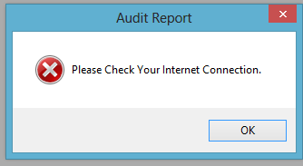
- Request you to solve this pop up: 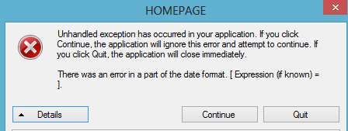
- Tym lag issue is very high
- Points as mentioned by you on mail by you.
- This pop up is wrong: 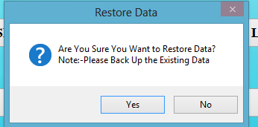 whereas it should say, Are you sure you want to Restore Data? Please note that all your earlier data will be wiped out.
Idea behind is that all previous should get wiped and new data should come in as restored.
- During Login, name of the Software in Big Bold The PIT Archive by Orion Legal Supplies should appear and Icon on top.
- Please update the publisher name to Orion Legal Supplies

